Postal Life Insurance

Department of Post

Software Requirements Specification (SRS)/ Functional Requirements Specification (FRS)
  - Mobile App for Agents

INTERNAL APPROVAL FORM

Project Name: Mobile App for Agents
Version: 1.0
Submitted on:
 | Name | Date
Approved By:
Reviewed By:
Prepared By:

VERSION CONTROL LOG
Version | Date | Prepared By | Remarks
1

Table of Contents

1. Executive Summary 4
2. Project Scope 4
3. Business Requirements 4
4. Functional Requirements Specification 6
4.1 Login Page 6
4.2 Home Page 6
4.3 Agent Diary & Tour Management Page 7
4.3.1 View Assigned Leads Page 7
4.3.2 Update Lead Status Page 7
4.3.3 Plan Your Daily Tour Page 8
4.3.4 Edit Tour Information Page 8
4.3.5 Tour Reports Page 8
4.4 Meeting Planner & Calendar Management page 9
4.4.1 Schedule Meeting Page 9
4.4.2 Update Meeting Outcome Page 9
4.5 Doorstep Customer Services page 9
4.6 My Business page 9
4.7 New Business page 10
5. Appendices 10

1. Executive Summary
To develop a comprehensive Mobile App for India Post PLI agents that enhances self-service capabilities, streamlines business processes, and improves agent productivity through mobile-first features such as push notifications, GPS integration, and offline support.

2. Project Scope
The mobile app will provide secure access to agent-specific data, policy management tools, commission tracking, customer engagement features, and support services optimized for Android and iOS platforms. It will include offline data capture, biometric login, and integration with device capabilities like GPS and camera.

3. Business Requirements

Requirement ID | Business Requirement | Description
FS_AM_001 | User Access & Authentication | The Mobile App should provide a secure OTP-based login system that verifies the identity of registered agents before granting access. It should also support session timeout and maintain detailed login logs to ensure data protection and auditability.
FS_AM_002 | Home Page & Dashboard | The home page should display a personalized dashboard showing business performance, key statistics like policies sold and commissions earned, and alerts for renewals or pending proposals. It should offer quick links to essential modules such as My Business, New Business, Reports, and Tools, ensuring a user-friendly experience across devices.
FS_AM_003 | Agent Diary & Tour Management | Agents should be able to plan and record their daily field visits, customer meetings, and follow-ups through an integrated diary and tour planner. The system should help them monitor completed activities, track expenses, and generate structured reports for supervisory review.
FS_AM_004 | Meeting Planner & Calendar Management | The meeting planner should allow agents to schedule customer or internal meetings with reminders and recurring options. It should also offer a calendar view for better time management and support synchronization with popular calendar tools like Google Calendar or Outlook.
FS_AM_005 | Doorstep Customer Services | Agents should be able to record service requests such as premium collection, policy updates, or document pickups during doorstep visits. The system should capture timestamps and service outcomes to ensure transparency and accountability in customer interactions.
FS_AM_006 | My Business | This module should allow agents to view their existing customer portfolios and policies, generate policy quotes, and track claims or renewals. It should also support commission tracking with detailed incentive statements, Disbursement History and provide lead management tools for capturing and converting potential customers.
FS_AM_007 | New Business | Agents should be able to generate premium quotes and benefit illustrations and submit new policy proposals digitally with e-KYC and e-sign features. The system should help track the proposal status and link with medical appointment scheduling where required.
FS_AM_008 | Performance Tracking | Agents should be able to monitor their progress against business targets through a dedicated performance dashboard. Supervisors should have visibility into overall performance metrics across agents or regions to assess productivity and identify improvement areas.
FS_AM_009 | Tools & Downloads | The Mobile App for Agent should provide downloadable resources such as policy servicing forms, brochures, and FAQs to support agents’ day-to-day operations. It should also offer calculators and product estimators to assist in customer advisory and policy planning.
FS_AM_010 | Reports | Agents should be able to generate and download a wide range of reports, including business, commission, incentive, and policy-related reports. These reports should be easy to filter, export, and interpret, providing a clear view of business performance and compliance requirements.
FS_AM_011 | User Profile Management | The user profile section should allow agents to update their personal details, upload KYC and bank information, and manage communication preferences. It should also notify them of license renewal deadlines and maintain their verified identification data securely.
FS_AM_012 | Learning & Development | A learning section should offer digital training modules, product tutorials, and certification programs to enhance agent skills. It should track learning progress and completion while keeping agents informed about new product updates and mandatory training sessions.
FS_AM_013 | Help & Support | The help section should include FAQs, guides, and tutorials to assist agents in resolving technical or operational queries. It should also enable them to raise support tickets, contact IT helpdesks, and receive timely responses through a centralized grievance management system.
FS_AM_014 | Document Management | The Mobile App for Agent should allow agents to securely upload and manage customer-related documents such as KYC proofs and policy forms. It should maintain version control, provide easy retrieval, and integrate with digital repositories for seamless document exchange.

4. Functional Requirements Specification
Flow Diagram for the Agent Mobile App:
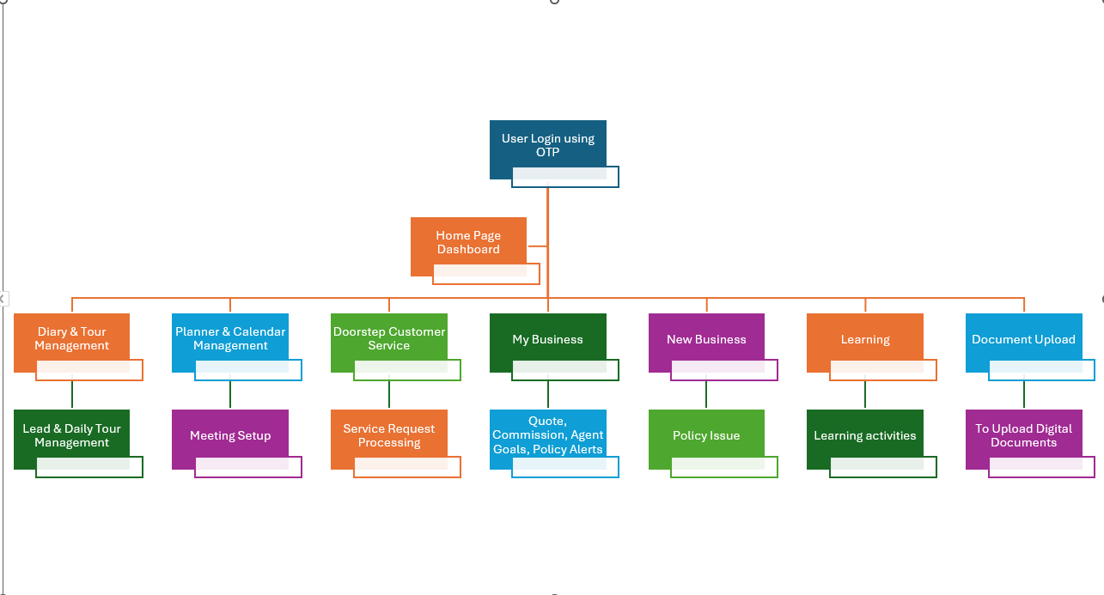

Login Page
Opening the Agent Mobile App
should open the Login Page.
- Fields:
  - Agent ID: Text
  - Password: Text
  - Login: Button
  - Forget Password: Link
- After Clicking Login:
  - OTP will be sent to the registered mobile number. The following fields will be displayed:
    - OTP: Text
    - Submit: Button
- Post Login
  - After successful login, the user should be navigated to the Agent Home Page.

Home Page
The Home Page will serve as the primary dashboard, showing key metrics, notifications, and quick navigation links to core modules. This page shows notifications for renewals, appointments, meetings, and new leads.
- Provide navigation tiles/links for all modules:
  - Agent Diary & Tour Management
  - Meeting Planner & Calendar Management
  - My Business
  - New Business
  - Doorstep Customer Services
  - Medical Appointment
  - Document Upload & Management
  - Tools & Downloads
  - Reports
  - User Profile
  - Learning
  - Help
  - Notifications
  - Logout link

Agent Diary & Tour Management Page
To record, plan, and manage daily tours and field activities of agents including lead management activities received.
- Fields:
  - View Assigned Leads: button
  - Create New Tour: button
  - Tour Report: button: To generate tour report
- Table:
  - The page should list all the previously created Tours in table format with ‘Edit’ button present for each row. Clicking on ‘Edit button' will move the user to ‘Edit Tour Information’ Page for that Tour.

View Assigned Leads Page
To allow agents to view leads assigned by supervisors or generated through system lead allocation.
- Table (non-editable) contain the following details of leads:
  - Lead Name
  - Contact Number
  - Email ID
  - Address
  - PIN Code
  - Source
  - Product Interested: Dropdown
  - Lead Type
  - Remarks
  - Status: Dropdown: Options are Not-Attended, In-Progress, Customer Not Interested, Policy Taken
  - Update Lead: link: Clicking this link should move the user to Update Lead status page.

Update Lead Status Page
To allow agents to update status of leads with comments.
- Fields:
  - Lead Name: Text
  - Contact Number: Text
  - Status: Text
  - Comments: Text
  - Submit: Button

Plan Your Daily Tour Page
To enable the agent to create a planned route for customer visits on a specific date.
- Fields:
  - Tour Date: Calendar
  - Location: Text
  - Purpose of Tour: Text
  - Customer Name: Text
  - Customer Mobile: Text
  - Customer Email: Text
  - Customer Address: Text
  - Product Interested: Dropdown
  - Status: Dropdown: Started, In-progress, Complete
  - Submit: button

Edit Tour Information Page
To update the details for any tour.
- Fields:
  - Tour Date: Calendar
  - Location: Text
  - Purpose of Tour: Text
  - Customer Name: Text
  - Customer Mobile: Text
  - Customer Email: Text
  - Customer Address: Text
  - Product Interested: Dropdown
  - Submit: button

Tour Reports Page
To view the reports for the tour.

- Fields:
  - Tour Start Date: Calendar
  - Tour End Date: Calendar
  - Status: Dropdown: Options are All, Started, In-Progress, Completed.
  - Generate Report: Button: Clicking this should generate the report as per filter given above in Excel format.

Meeting Planner & Calendar Management page
To plan and schedule customer meetings, team meetings, and training sessions.
- Fields:
  - Scheduled Meetings & Training Sessions: Table: Display the currently scheduled customer meetings, team meetings, and training sessions with ‘Update’ link beside each meeting to Update Meeting Outcomes.
  - Schedule Meeting: button

Schedule Meeting Page
- Fields:
  - Meeting Type: Dropdown: Options are ‘Customer Meeting’, ‘Team Meeting’ and ‘Training Session’.
  - Automatic Reminder Date: Calendar
  - Automatic Reminder Time: Timestamp
  - Meeting Details: Text

Update Meeting Outcome Page
- Fields:
  - List of Attendees: Auto-populate: It should auto-populate the list of attendees who have attended the meeting.
  - Meeting Details: Text
  - Meeting Outcome: Text
  - Submit: Button

Doorstep Customer Services page
The page is used to view the lead management report and service request
- Fields:
  - New Service Request: button
  - Lead Management: button
  - Service Request Information: Table: There should be a table with list of previously raised service requests along with status and option to ‘Update’ beside each of the service requests.
  - Generate Report: button: To download the list of service requests along with status in excel format.
- Rules:
  - Clicking ‘New Service Request’ should move the user to ‘New Service Request’ page for creating new service request for the client.
  - Clicking 'Lead Management’ should move the user to ‘View Assigned Lead Page’.

New Service Request Page
The page should be used to create new service requests for the customers.

- Fields:
  - Request Type: Mandatory
  - Policy Number: Option to search & select the policy should be present
  - Paid to Date: Mandatory
  - Intimator First Name: Mandatory for Death Claim Only
  - Intimator Middle Name: Mandatory for Death Claim Only
  - Intimator Last Name: Mandatory for Death Claim Only
  - Intimator Rel to Insured: Mandatory for Death Claim Only
  - Intimator Phone Number: Mandatory for Death Claim Only
  - Date Of Death: Mandatory for Death Claim Only
  - Disputed Reason: Optional
  - Primary Insured: Optional
  - Secondary Insured: Optional
  - Mandatory Document: Option to Upload Document should be there.
  - Service Request Date: Mandatory
  - Policy Number: Mandatory
  - Office Code: Mandatory
  - Service Request Channel: Mandatory
  - Username: Mandatory
  - Submit: button

My Business page
My business page will display the links for current business related aspects for the agent.
- Fields:
  - Claims Management & Quotes Generation: button
  - Commission & Incentive Tracking: button
  - Business Performance Tracking: button

Claims Management Dashboard Page
- Purpose: To generate the quote for Policy Loan, Surrender, Revival and Reduced Paid-up for the policy.
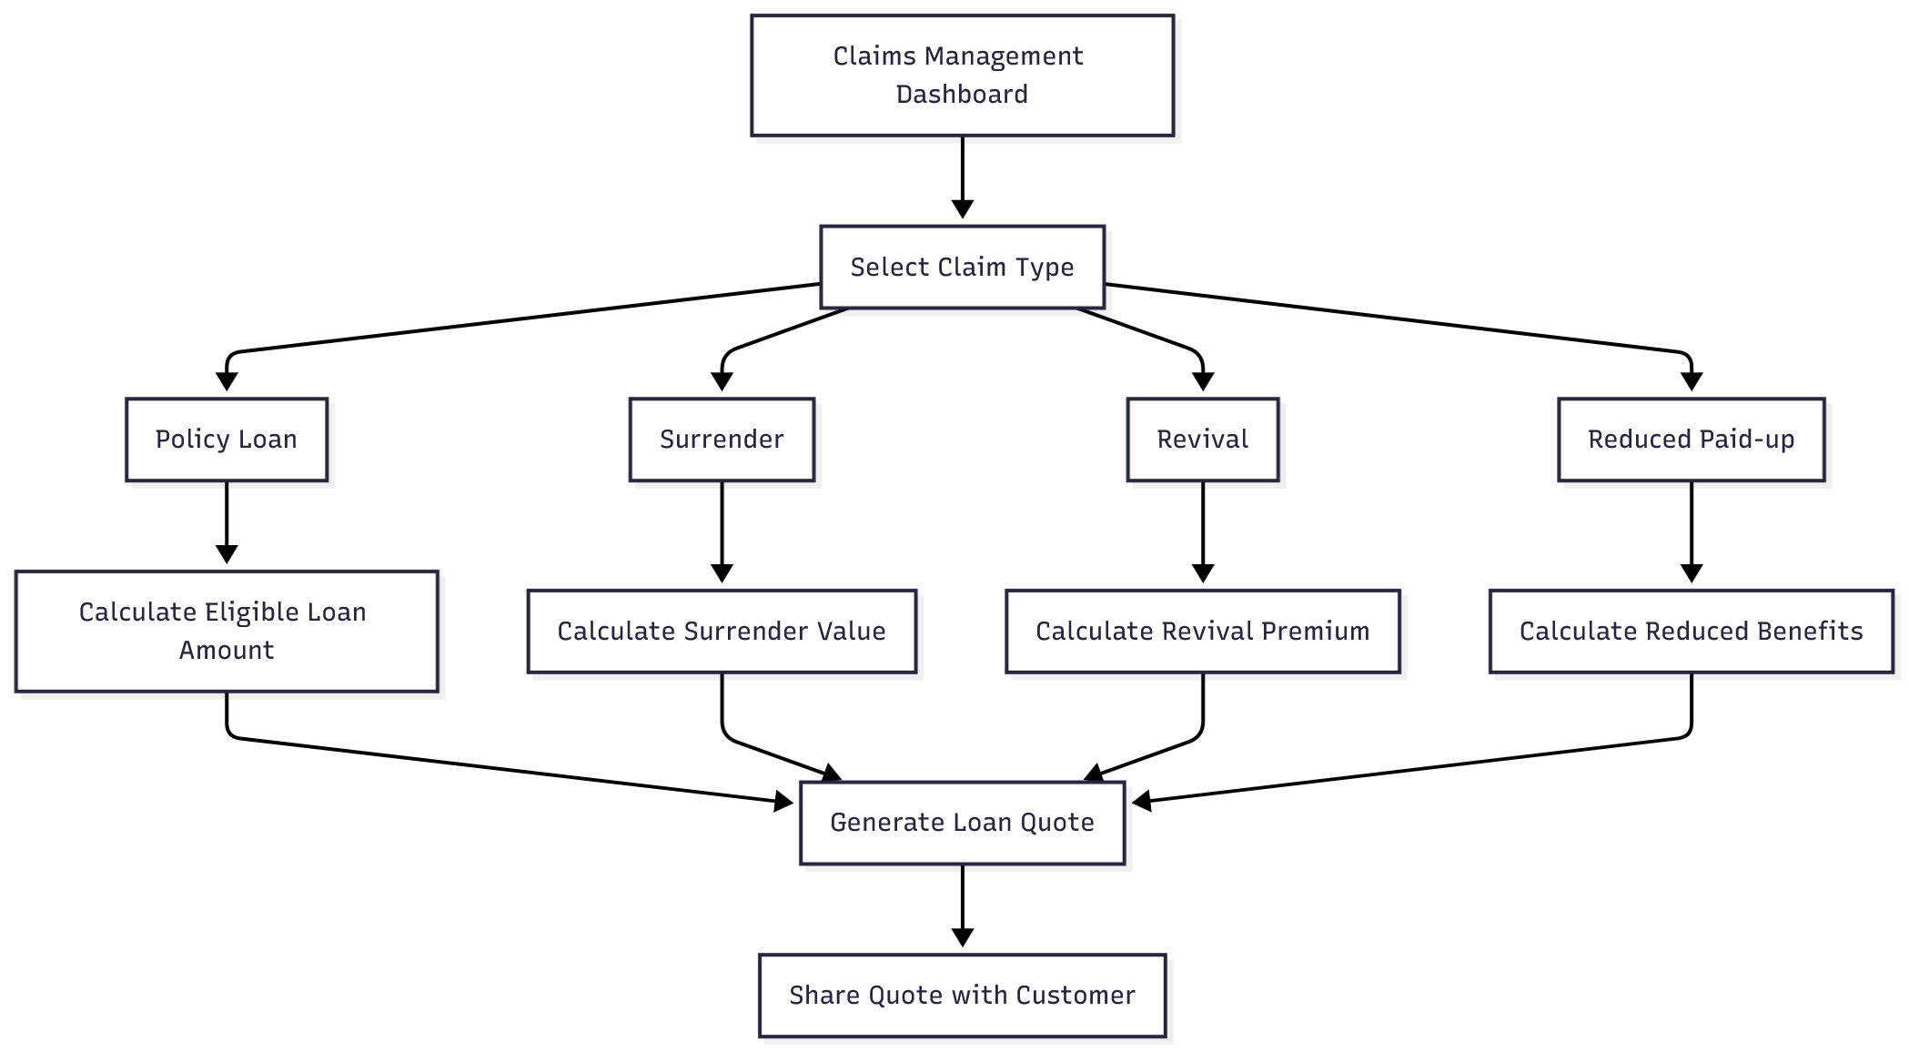

4.6.2 Commission Tracking Page
- Purpose: To view the commission for the agent and to generate commission and tax statements.
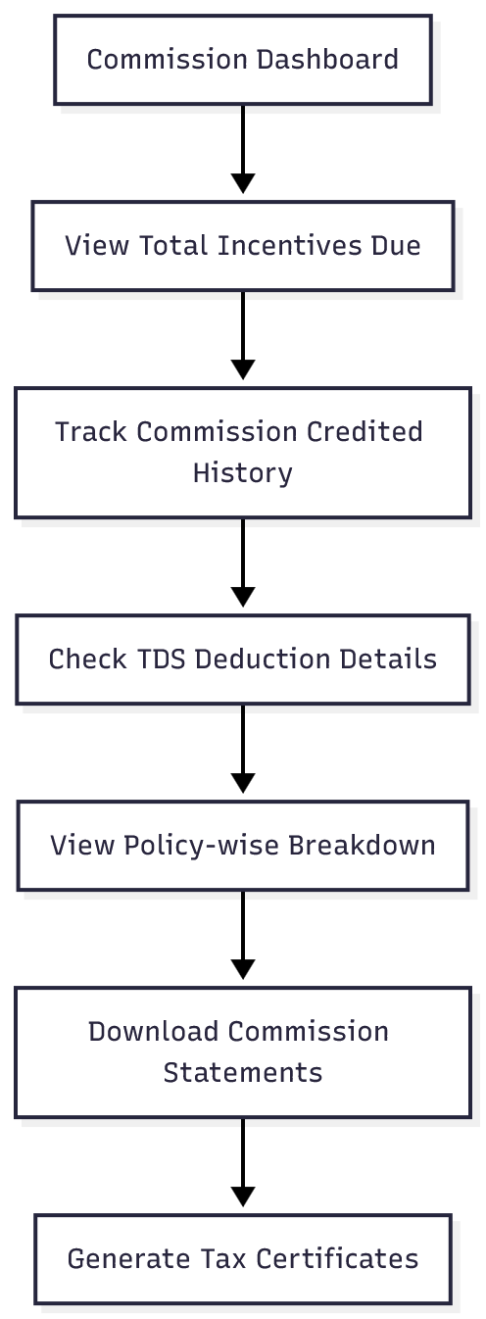

Business Performance Tracking Page
- Purpose: To view the Agent Goals and to check if the target is getting achieved by the agent.
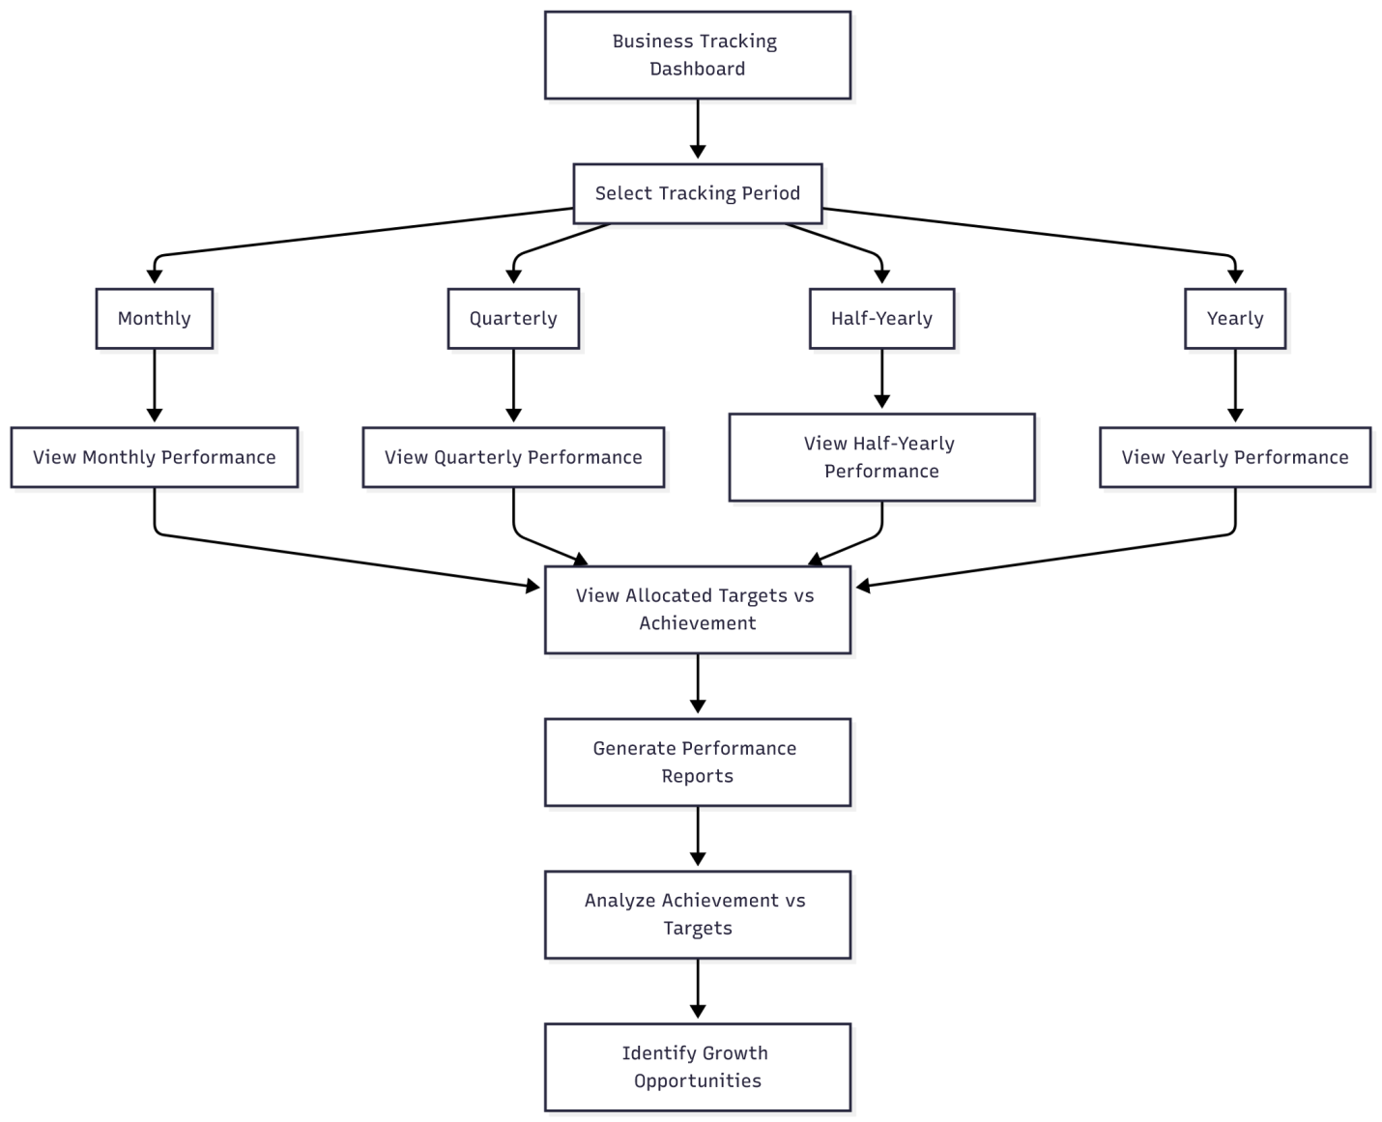

Customer Management & Policy Alerts
- Purpose: To view the status of policies for the agent and to send the revival offers for the agents.
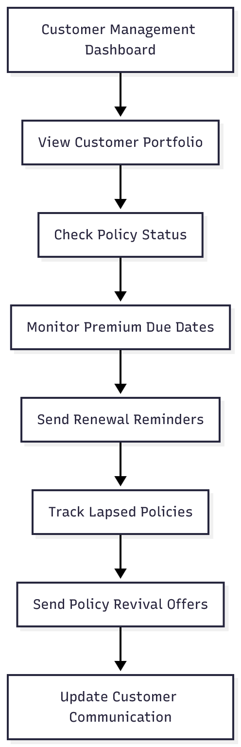

New Business page

New Business Issuance
- Purpose: To perform the process of policy issue by the agent.
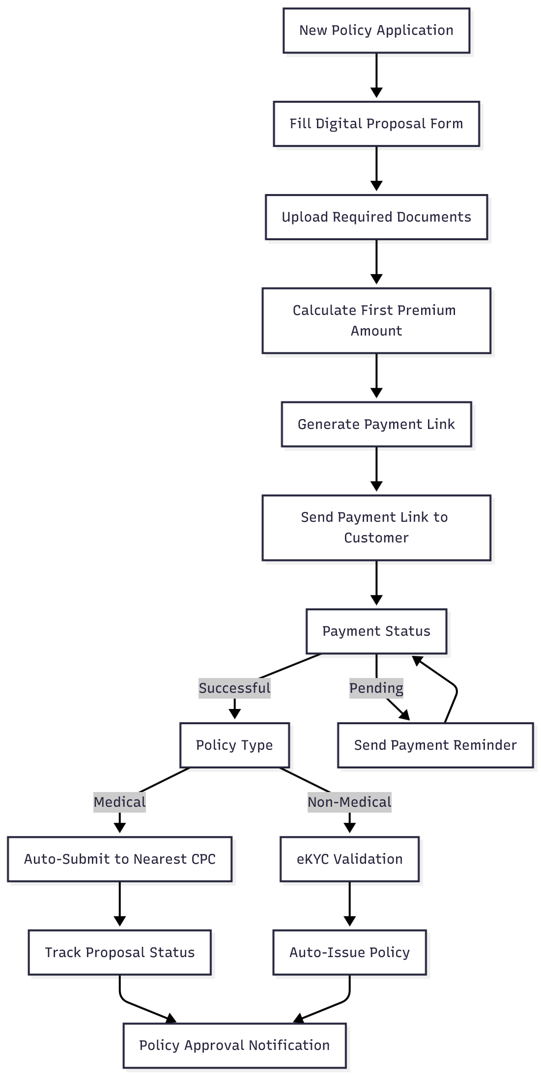

Medical Examination Management
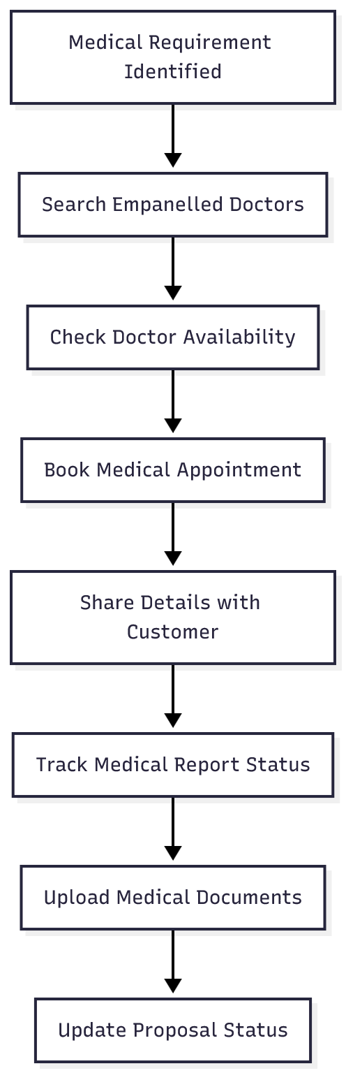

Pending Policies Tracking
- Purpose: To track the status of pending applications.
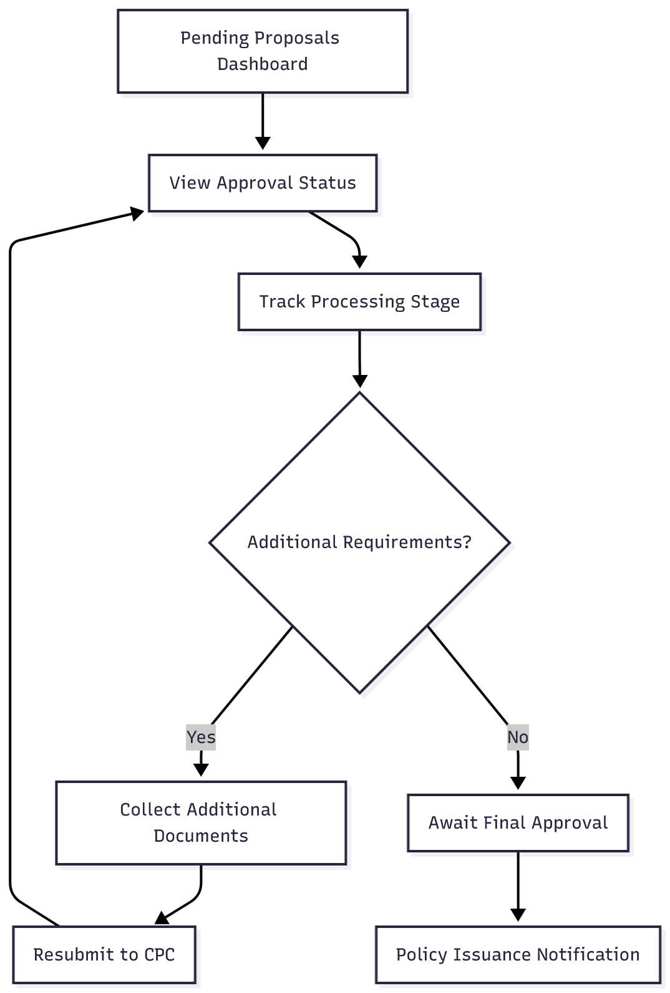

Digital Learning & Product Information
To Access the Information related to PLI/RPLI Products and for other learning activities.
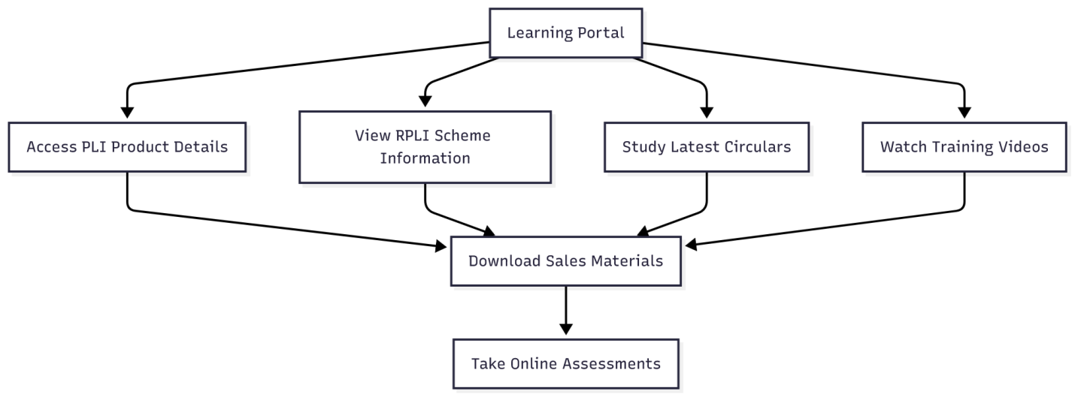

Document Upload page
The page is used to upload the documents to be sent to CPC and PO for processing.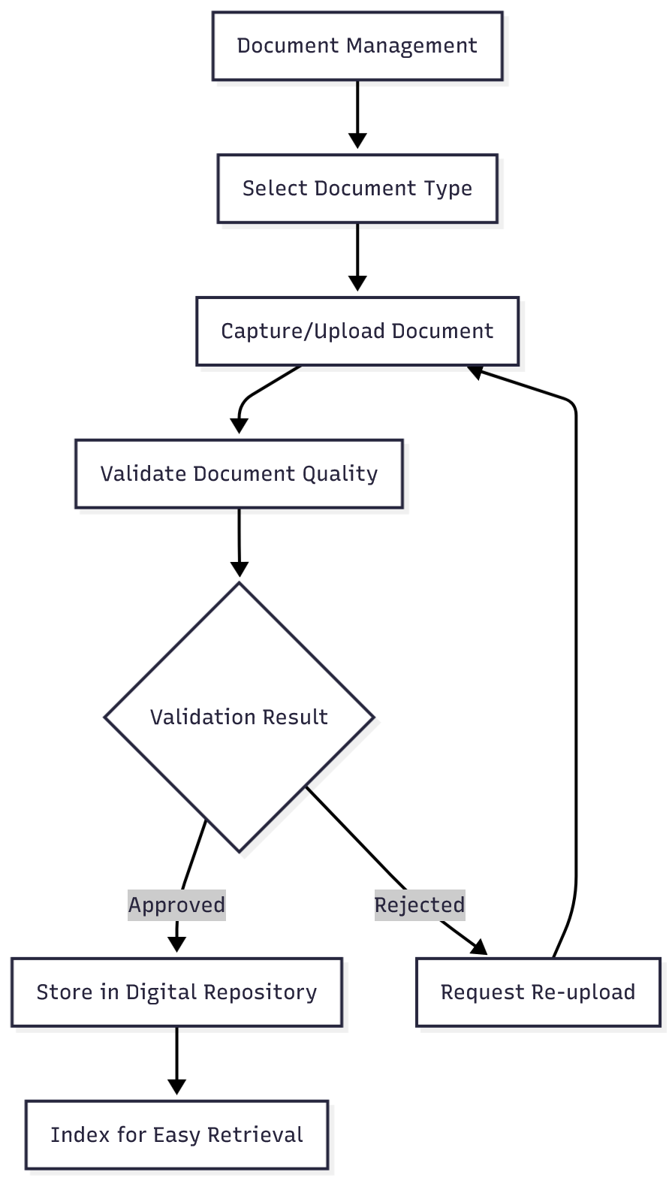

5. Appendices
The Following Documents attached below can be used.

